Chemistry

Unit 8
Gases

Set 32.0: Kinetic Theory of Gases

Skill 32.01: Describe an ideal gas
Skill 32.02: Compare the rates of effusion and diffusion for different gases
Skill 32.03: Describe the conditions under which a gas will deviate from ideal behavior

Skill 32.01: Describe an ideal gas

Skill 32.01 Concepts

The word kinetic comes from the Greek word kinetikos, which means “moving”. The kinetic theory of matter is based on the idea that particles of matter are always moving and can be used to explain the properties of gases, liquids, and solids.

An ideal gas is an imaginary gas that conforms perfectly to the following assumptions:

- Gases consist of large numbers of tiny particles. The size of the particles which make up the gases are insignificant compared to the distance between the particles.
- The particles of a gas are in constant motion, that is they posses kinetic energy
- The collisions between the particles of a gas are elastic, that is there is no loss in energy.
- There are no forces of attraction or repulsion between the particles of a gas
- The average kinetic energy of the particles of a gas is directly proportional to its temperature, ONLY
- The speed at which a gas particle travels is inversely proportional to the square of its molecular mass. Small gas particles travel faster than large gas particles.

Although ideal gases do not actually exist, the behavior of many gases conforms to the assumptions above at very high temperatures and very low pressures.

Skill 32.01 Example 1
(a) Compare the kinetic energy of NH₃ to HCl at 25ºC.
(b) Compare the velocities of NH₃ to HCl at 25ºC.

Skill 32.01 Example 2
Consider the following diagrams representing different “gas” samples.
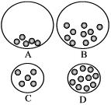
Which gas would behave most like an ideal gas? Explain.

Skill 32.02: Compare the rates of effusion and diffusion for different gases

Skill 32.02 Concepts

Effusion is the term used to describe the passage of a gas through a tiny hole. The rate of effusion is inversely proportional to the square root of the mass of its particles. Unlike the kinetic energy, effusion DOES depend on the size of the molecule: the bigger the molecule, the slower it effuses, and vice versa. Table 1 summarizes this fact.

Table 1. Comparison of effusion rates, and diffusion rates and kinetic energy
Molecule | H₂ | CH₄ | CO₂
Mass (g/mol) | 2.016 | 16.04 | 44.01
Kinetic energy (J/molecule) | 6.213 x 10⁻²¹ | 6.213 x 10⁻²¹ | 6.213 x 10⁻²¹
Rate of effusion (m/s) | 1,926 | 683.8 | 412.4
Rate of diffusion (m/s) | 1,926 | 683.8 | 412.4

Diffusion is the term used to describe how quickly two gases will mix. Like effusion, the rate at which a molecule diffuses is also dependent on the size of the molecule: the bigger the molecule, the slower it diffuses, and vice versa. This fact is also summarized in table 1.

Skill 32.02 Example 1
The balloons shown have identical volumes and are under the same conditions of temperature and pressure. Each balloon contains the same number of
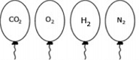
- Compare the kinetic energy of the molecules in each balloon. Explain.
- If a pin-hole sized leaked developed in each balloon, which balloon would be the smallest after minutes? Explain
- If each balloon was popped with a pin, the molecules in which balloon would diffuse most quickly? Explain.

Skill 32.03: Describe the conditions under which a gas will deviate from ideal behavior

Skill 32.03 Concepts

In 1873 Johannes van der Waals proposed that real gases deviate from ideal behavior because (1) particles of real gases occupy space and (2) particles of real gases exert attractive forces on each other.

In general, gases that most closely obey ideal behavior are

(1) small
(2) nonpolar (are symmetrical)
(3) exist at high temperature and low pressure

Concept 32.03 Example 1
Under which conditions will helium gas behave most ideally? Explain.  (a) 100 K and 1 atm  (b) 200 K and 2 atm  (c) 0 K and 0.5 atm  (d) 200 K and .5 atm | Under which conditions will helium gas deviate the most from ideal behavior? Explain.  (a) 100 K and 1 atm  (b) 200 K and 2 atm  (c) 0 K and 2.0 atm  (d) 200 K and .5 atm

Concept 32.03 Example 2
Which of the following (nonpolar) gases below will behave most ideally? Least ideally at STP?

CO₂, H₂, Ar, N₂, O₂, C₂H₆

Concept 32.03 Example 3
(a) Classify each molecule as polar or nonpolar
(b) Which molecule will deviate the most from ideal behavior? The least? Explain.

CO₂, H₂O, NH₃, Ar, He, H₂S

Skill 32.03 Example 4
Consider the following diagrams representing different gas samples all at the same temperature.
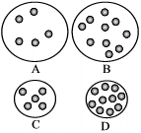
Which gas would deviate most from ideal behavior?

Set 32.0 Practice Problems

- An ideal gas at 25ºC was compressed at constant temperature as shown below. Explain the effects, if any, on each of the following:
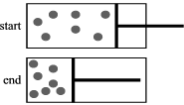

- The kinetic energy of the molecules
- The speed of the molecules
- The density of the molecules

- Samples of CO(g) and CO₂(g) are placed in 1 L containers at the conditions indicated in the diagram.

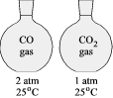

  - Indicate whether the average kinetic energy of the CO₂(g) molecules is greater than, equal to, or less than the average kinetic energy of the CO(g) molecules. Justify your answer.

  - Indicate whether the average speed of the CO₂(g) molecules is greater than, equal to, or less than the average speed of the CO(g) molecules. Justify your answer.

- Which gas below will behave most ideally at 25ºC? Which will deviate the most? Explain.

He, N₂, O₂, CO₂

- Which gas below will behave most ideally at 25ºC? Which will deviate the most? Explain.

CO₂, NH₃, H₂O

- Which balloon will the molecules or atoms behave most ideally at 25ºC? In which will they deviate the most? Explain.

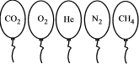

- Which balloon will the molecules or atoms behave most ideally at 25ºC? In which will they deviate the most? Explain.

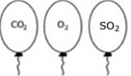

- The four flasks shown contain equal amounts of different gases at STP. In which flask will the molecules or atoms behave most ideally at 25ºC? In which will they deviate the most? Explain.
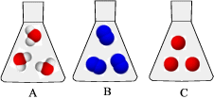

- Which of the following substances would deviate most from ideal behavior? Explain.
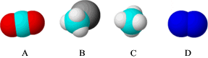

- Which of the following substances would behave most ideally? Explain
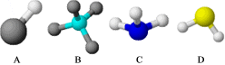

Set 33: Combined Gas Law

Skill 33.01: Define pressure, explain how it is measured
Skill 33.02: Be able to define and convert between, atm, torr, and mm Hg
Skill 33.03: Define standard temperature and pressure
Skill 33.04: State Boyle’s law and use it to calculate volume – pressure changes at fixed temperature.
Skill 33.05: State Charles’s law and use it to calculate volume – temperature changes at fixed pressure.
Skill 33.06: State Gay-Lussac’s law and use it to calculate pressure-temperature changes at fixed volume
Skill 33.07: Use the combined gas law to calculate volume-temperature-pressure changes

Skill 33.01: Define pressure, explain how it is measured

Skill 33.01 Concepts

Pressure is defined as the force per unit area on a surface (force/area). A barometer is an instrument used for measuring pressure (figure 1)

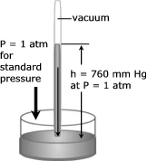 | Figure 1. A barometer is constructed by filling a glass tube with liquid mercury and inverting it in a dish of mercury. Notice that a large quantity of mercury stays in the tube. In fact, at sea level the height of this column of mercury averages 760 mm.

Skill 33.01 Example 1
How would the height of the mercury in the barometer change

- On Mount Rainier?
- 66 feet below the surface of the ocean?

Skill 33.02: Identify the steps required to solve each type of stoichiometry problem

Skill 33.02 Concepts

A number of different units are used to measure pressure. Some pressure units are based on force per unit area, some on mass per unit area, and others on the height of a liquid column. Because atmospheric pressure is traditionally measured by a mercury barometer scientist often express pressure in terms of the height of a column of mercury. Thus a common unit of pressure is millimeters of mercury (mm Hg). The average atmospheric pressure at sea level and 0ºC is 760 mm Hg. To honor Torricelli for his invention of the barometer, a pressure unit named after him, the torr, has been introduced. By definition 1 torr=1 mm Hg.

High pressures are often measured in units of atmospheres. One atmosphere of pressure (atm) is defined as being equal to the average sea level pressure at 0ºC. Thus 1 atm = 760 mm Hg = 760 torr. These units of pressure are summarized in table 1.

Table 1. Units of pressure
Unit | Symbol | Definition
Millimeter of mercury | mm Hg | Pressure that supports a 1-mm mercury column in a barometer
Torr | Torr | 1 torr = 1 mm Hg
Atmosphere | Atm | 1 atm = 760 mm Hg = 760 torr

Skill 33.02 Example 1
The atmospheric pressure in Denver, Colorado, on the average is 0.830 atm. Express this pressure in
- mm Hg
- torr

Skill 33.03: Define standard temperature and pressure

Skill 33.03 Concepts

The volume of a gas depends upon temperature and pressure. Therefore, in order to compare volumes of gases, it is necessary to know the temperature and pressure at which the volumes are measured. To aid in such comparisons, scientist have agreed upon standard conditions of exactly 1 atm and 0ºC. These conditions are standard temperature and pressure and are commonly abbreviated STP.

Skill 33.03 Example 1
Which of the following indicate STP conditions,
- 273 K and 760 mm Hg
- 0 K and 1 torr
- 0ºC and 760 torr
- 273 K and 760 torr

Skill 33.04: State Boyle’s law and use it to calculate volume – pressure changes at fixed temperature.

Skill 33.04 Concepts

The first quantitative experiments on gases were performed by Robert Boyle. Using a J-shaped tube like that shown below, he studied the relationship between the pressure of a trapped gas and its volume.

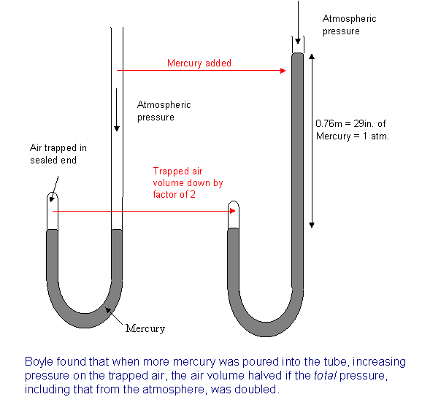
Figure 2. Boyle’s Apparatus

Robert Boyle discovered that the volume of a fixed mass of gas varies inversely with the pressure at constant temperature. In other words, he found that doubling the pressure on a sample of gas (by adding more mercury) at constant temperature reduced its volume one-half; tripling the gas pressure reduced its volume to one-third; while, reducing the pressure on a gas by one-half allowed the volume of the gas to double. This relationship is shown graphically in figure 3.

Figure 3. The variation of volume with pressure at constant temperature
100
50
Pressure
volume
20
40
60

In order to make the plot in figure appear linear, on simply needs to plot the inverse of one of the variables. This shown in figure 4.

Figure 4. The variation of volume with pressure at constant temperature
100
50
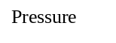
1/volume
20
40
60
Point 1
Point 2

In figure 4, the slope is a constant value equal to the following expression,

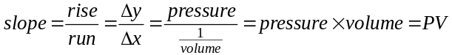

Notice that the slope is constant regardless of the point on the line. In other words

slope at point 1 = slope at point 2

OR

P₁V₁=P₂V₂ (Boyle’s Law)
The use of the relationship above, known as Boyles Law, is illustrated below.

Example

If 1.0 L of gas at 1.0 atm is allowed to expand at constant temperature to 5.0 L what is the new pressure?

Solution

The initial conditions of the gas are defined as follows:

P₁ = 1.0 atm
V₁ = 1.0 L

The final conditions of the gas are defined as follows:

P₂ = ?
V₂ = 5.0 L

Substituting into Boyle’s Law equation and solving,

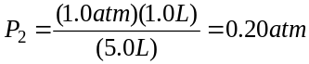

Skill 33.04 Example 1
A sample of oxygen gas collected in the laboratory occupies a volume of 150 mL when its pressure is 720 mm Hg. What volume will the gas occupy at a pressure of 750 mm Hg if the temperature remains constant?

Skill 33.05: State Charles’s law and use it to calculate volume – temperature changes at fixed pressure.

Skill 33.05 Concepts

The French scientist Jacques Charles discovered that the volume of a gas varies directly with its temperature at constant pressure. In other words, he found that doubling the temperature of a sample of gas at constant pressure doubled its volume; tripling the gas temperature, tripled its volume; while, reducing the temperature of a gas by one-half caused the volume of the gas to reduce proportionally. This relationship is shown graphically in figure 5.

Figure 5. The variation of volume with temperature at constant pressure
100
50
Temperature (K)
273
546
819
Point 1
Point 2
volume

In figure 5, the slope is a constant value equal to the following expression,

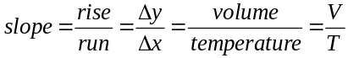

Notice that the slope is constant regardless of the point on the line. In other words

slope at point 1 = slope at point 2

OR

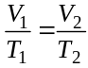 (Charles’s Law)

The relationship above is known as Charles’s Law. Keep in mind, when using Charles’s law, the temperature must be expressed in Kelvin. Recall the conversion factor between Kelvin and Celsius temperatures is as follows,

K = 273.15 + ºC

Skill 33.05 Example 1
A sample of neon gas occupies a volume of 752 mL at 0ºC. What volume will the gas occupy if the temperature is doubled?

Skill 33.06: State Gay-Lussac’s law and use it to calculate pressure-temperature changes at fixed volume

Skill 33.06 Concepts

Joseph Gay-Lussac is credited for recognizing that a quantity of gas at a fixed volume is directly proportional to its temperature in Kelvin. In other words, he found that doubling the temperature of a sample of gas at constant volume doubled its pressure; tripling the gas temperature, tripled its pressure; while, reducing the temperature of a gas by one-half reduced the pressure of the gas proportionally. This relationship is shown graphically in figure 6.

Figure 6. The variation of volume with temperature at constant pressure
100
50
Temperature (K)
273
546
819
Point 1
Point 2
pressure

In figure 6, the slope is a constant value equal to the following expression,

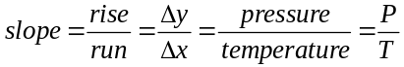

Notice that the slope is constant regardless of the point on the line. In other words

slope at point 1 = slope at point 2

OR

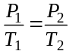 (Gay-Lussac’s Law)

The relationship above is known as Gay-Lussac’s Law. Keep in mind, when using Gay-Lussac’s law, the temperature must be expressed in Kelvin.

Skill 33.06 Example 1
The gaseous contents in an aerosol can are under a pressure of 3.00 atm at 25ºC. Directions on the can caution the user to keep the can in a place where the temperature does not exceed 52ºC. What would the pressure of the gas in the aerosol can be at 52ºC?

Skill 33.07: Use the combined gas law to calculate volume-temperature-pressure changes

Skill 33.07 Concepts

A gas sample often undergoes simultaneous changes in temperature, pressure, and volume. When this happens, three variables must be dealt with at once. Boyle’s law, Charles’s law, and Gay-Lussac’s law can be combined into a single expression that describes a relationship that is useful in such situations. This relationship, known as the combined gas law, expresses the relationship between pressure, volume, and temperature of a gas when the amount of gas is fixed,

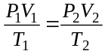

P₁, V₁, T₁ are the initial pressure, volume, and temperature of the gas respectively.
P₂, V₂, T₂ are the final pressure, volume and temperature of the gas respectively.

Example

A helium filled balloon has volume of 50.0 L at 25ºC and 820 mm Hg. What volume will it occupy at 650 mm Hg and 10ºC?

Solution

Step 1: Identify all the variables which are given in the problem. P₁ = 820 mm Hg, V₁ = 50.0 L, and T₁ = 25ºC + 273 = 298 K, P₂ = 650 mm Hg, T₂ = 10ºC + 273 = 283 K

Step 2: Identify you unknown. The problem asks for the final pressure, V₂

Step 3: substitute and solve,

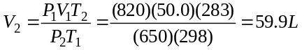

Skill 33.07 Example 1
The volume of a gas is 27.5 mL at 22.0ºC and 740. mm Hg pressure. What will be its volume at 15ºC and 755 mm Hg pressure?

Table 2. Gas law summary
Law | Conditions | Equation
Boyle’s | Constant temperature | P₁V₁=P₂V₂
Charles’s | Constant pressure
Gay-Lussac’s | Constant volume
Combined gas law | -

Set 33 Practice Problems

- What is the height, h, of the column of mercury in the figure?
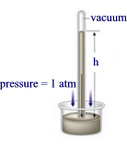
- If the pressure reading is given as 273 mm Hg, what would this be in atmospheres?

- If the pressure reading is given as 2.1 atm, what would this be in torr?

- A helium-filled balloon has a volume of 30.0 L at 25ºC and 1.00 atm. What volume will it have at 0.900 atm and 15ºC?

- The volume of a gas is 27.5 mL at 22ºc and 0.974 atm. What will the volume be at 15.0ºC and 0.993 atm?

- A 700. mL gas sample at STP (STP means standard temperature and pressure: temperature = 273 K and P = 1 atm) is compressed to a volume of 200. mL, and the temperature is increased to 30.0ºC. What is the new pressure of the gas?

- A sample of neon gas occupies a volume of 752 mL at 25oC. What volume will the gas occupy at 50ºC if the pressure remains constant?

- A sample of oxygen gas in a 3.5 L container at 273 K is heated at 1 atm until the pressure doubles. What is the new temperature?

- Which curve represents the relationship between the volume of an ideal gas and its temperature in Kelvins at constant pressure?
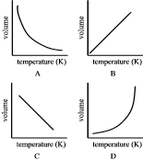

- Which graph represents the relationship between the pressure of an ideal gas and its temperature in Kelvins at constant volume?
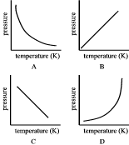
- Which graph represents the relationship between the pressure and volume of an ideal gas at constant temperature?
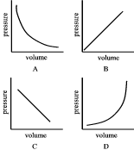

Set 34: Ideal Gas Law

Skill 34.01: State Avogadro’s principle and use it to calculate volume – mole changes at fixed pressure and temperature
Skill 34.02: State the ideal gas law and derive the ideal gas constant
Skill 34.03: Using the ideal gas law, calculate pressure, volume, temperature, or the amount of gas, when give the other three are known.

Skill 34.01: State Avogadro’s principle and use it to calculate volume – mole changes at fixed pressure and temperature

Skills 34.01 Concepts

As gas is added to a balloon, its volume expands. The relationship between the quantity of a gas and its volume follows from the work of Joseph Louis Gay-Lussac (1778-1823) and Amedeo Avogadro (1776-1856). Gay-Lussac observed the law of combining volumes: At a given pressure and temperature, the volumes of gases that react with one another are in the ratios of small whole numbers. For example, two volumes of hydrogen gas react with one volume of oxygen gas to form two volumes of water vapor.

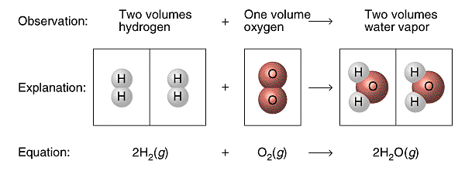
Figure 1. Law of combining volumes

Three years later Amedeo Avogadro interpreted Gay-Lussac’s observation by proposing what is now known as Avogadro’s hypothesis: Equal volumes of gases at the same temperature and pressure contain equal numbers of molecules. For example, experiments show that 22.4 L of any gas at 0ºC and 1 atm contain 6.022 x 1023 gas molecules (that is, 1 mol).

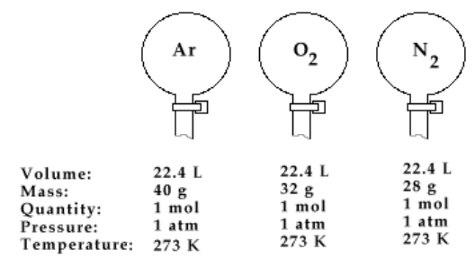
Figure 2. Avogadro’s hypothesis

Avogadro’s law follows from Avogadro’s hypothesis: The volume of a gas maintained at constant temperature and pressure is directly proportional to the number of moles of gas (Figure 3).
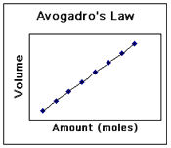
Figure 3. Avogadro’s law

Skill 34.01 Example 1
Gas is confined to the cylinder shown below,

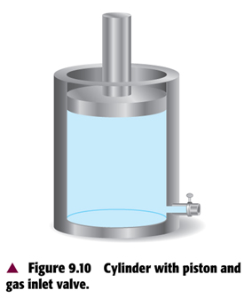

If additional gas is injected into the cylinder through the gas inlet valve, indicate how this change affects the
- average distance between the molecules

- the average energy of the molecules

- the pressure of the gas

(d) the number of moles of gas in the cylinder

Skill 34.01 Example 2
The picture shows hydrogen (light) and oxygen (dark) molecules at the start of a reaction. The container in which the molecules are confined is flexible. The molecules react to form water. At the “start” of the reaction, the volume of the reactant mixture is 6.0 L.
- What is the volume of the products at the “finish” of the reaction?
- Draw a picture that represents the reaction mixture and at the “finish” of the reaction.
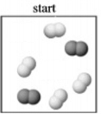

Skill 34.01 Example 3
(a) According to figure 2, what does one mole of gas occupy at STP? (Molar volume)

(b) A chemical reaction is expected to produce 0.0680 mol of oxygen gas. What volume in liters will be occupied by this gas sample at STP?

(c) What is the mass in grams occupied by 11.2 L of oxygen gas (O₂)?

(d) What volume in liters is occupied by 14.0 g of nitrogen gas (N₂)?

Skill 34.02: State the ideal gas law and derive the ideal gas constant

Skill 34.02 Concepts

Combining Boyle’s law, Charles’s law, Gay-lussac’s law, and Avogadro’s principle into a single expression gives a general equation which relates the four measurable quantities: pressure, volume, temperature, and moles of a gas. This general equation, also called the ideal gas law, can be used to calculate the unknown information about gas sample,

PV = nRT

In the above equation, P is pressure in atmospheres, V is volume in liters, n is moles, and T is temperature in Kelvin. R is called the ideal gas constant. Solving for R,

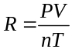

The below example illustrates how the value of R can be determined.

Skill 34.02 Example 1
Potassium chlorate decomposes upon heated according to the following equation,

2KClO₃ → KCl + 3O₂

A student conducted an experiment and recorded the data shown below,

Mass KClO₃ (g) | 5.0
Mass KCl recovered (g) | 1.7
Temp water (ºC) | 23
Volume O₂ (mL) | 2500
Pressure (atm) | 1.0

What is R, the ideal gas constant?

Skill 34.03: Using the ideal gas law, calculate pressure, volume, temperature, or the amount of gas, when give the other three are known.

Skill 34.03 Concepts

In the previous example you determined the ideal gas law constant, R. The actual value of the ideal gas law constant is 0.0821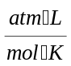. Now that the ideal gas constant R is known, the relationship, PV = nRT can be used to calculate the pressure, volume, temperature, or the amount of gas, when give the other three are known.

Consider the following example,

Example

What is the pressure in atmospheres exerted by a 0.500 mol sample of nitrogen in a 10.0 L container at 298K

Solution

Given: V = 10.0 L; n = 0.500 mol; T = 298 K
Unknown: P

Substituting and solving,

PV = nRT

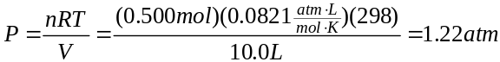

Skill 34.03 Example 1
What is the volume in liters of 1.00 mol of N₂ gas at a STP. (Recall STP stands for Standard Temperature and Pressure. That is where P = 1 atm and T = 273 K)

Skill 34.03 Example 2
What is the pressure of 8.00 g of oxygen gas (O₂) when the pressure is 758 mm Hg and the temperature is 25ºC?

Set 34.0 Practice Problems

- What is the volume of, in liters, of each of the following at STP?

- 1.00 mol O₂

- 3.50 mol F₂

- 0.0400 mol CO₂

- 1.2 x 10⁻⁶ mol He

- How many moles are contained in each of the following at STP?

- 22.4 L N₂

- 5.6 L Cl₂

- 0.125 L Ne

- 70.0 mL NH₃

- Find the mass, in grams, of each of the following at STP:

- 11.2 L H₂

- 15.0 mL SO₂

- 2.80 L CO₂

- 3.40 cm³ F₂

- Find the volume, in liters, of each of the following at STP:

- 8.00 g O₂

- 3.50 g CO

- 0.0170 g H₂S

- 2.25 x 10⁵ kg NH₃

- Calculate the pressure, in atmospheres, exerted by each of the following:

- 2.50 L of HF containing 1.35 mol at 320 K.

- 4.75 L of NO₂ containing 0.86 mol at 300. K

- 750. mL of CO₂ containing 2.15 mol at 57ºC.

- Calculate the volume, in liters, occupied by each of the following:

- 2.00 mol of H2 at 300 K and 1.25 atm

- 0.425 mol of NH3 at 37ºC and 550 mm Hg

- 4.00 g of O₂ at 57ºC and 675 mm Hg.

- Determine the number of moles of gas contained in each of the following.

- 1.25 L at 250 K and 1.06 atm

- 0.80 L at 27oC and 0.925 atm

- 750 mL at -50ºC and 700 mm Hg

- Find the mass of each of the following.

- 5.60 L of O₂ at 1.75 atm and 250 K

- 3.50 L of NH₃ at 700 mm Hg and 27ºC

- 125 mL of SO₂ at 625 mm Hg and -53ºC

- What is the pressure in atmospheres exerted by a 0.500 mol sample of nitrogen in a 10.0 L container at 298K?

- What is the volume in liters occupied by 0.250 mol of oxygen at 20.0ºC and 740 mm Hg pressure?

- What is the mass of chlorine (Cl₂), in grams, contained in a 10.0 L tank at 27ºC and 3.50 atm?

- What pressure, in atmospheres, is exerted by 0.325 mol of hydrogen gas (H₂) in a 4.08 L container at 35ºC?

- What is the mass, in grams, of oxygen (O₂) in a 12.5 L container 45ºC and 7.22 atm?

Set 35.0: Ideal Gas Law Applications

Skill 35.01: Use Dalton’s law of partial pressures to calculate partial pressures and total pressures
Skill 35.02: Calculate the pressure of a gas collected by water displacement
Skill 35.03: Use the ideal gas law to calculate the molar mass of a gas
Skill 35.04: Use the ideal gas law to calculate the density of a gas

Skill 35.01: Use Dalton’s law of partial pressures to calculate partial pressures and total pressures

Skill 35.01 Concepts

Thus far we have concentrated on the behavior or pure gaseous substances, but experimental studies often involve mixture of gases. In this case, and all cases involving mixtures of gases, the total gas pressure is related to partial pressures, that is, the pressures of the individual gas components in the mixture. Dalton’s law of partial pressures states that the total pressure of a mixture of gases is just the sum of the pressures that each gas would exert if it were present alone.

Consider the case in which two gases, A and B, are in a container of volume V. The pressure exerted by gas A is P_{A} the pressure exerted by gas B is P_{B}. The total pressure P_{T} is the result of the collision of both types of molecules A and B, with the walls of the container. Thus,

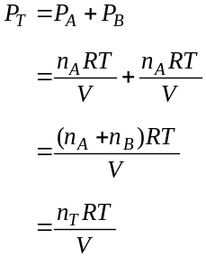

Notice that the total pressure is depends on the total number of moles present only, not the nature of the gas molecules.

Skill 35.01 Example 1
3.0 moles of oxygen gas and 1.0 mole of nitrogen gas are confined to a 5.0 L container at 273 K. What is the total pressure?

Skill 35.02: Calculate the pressure of a gas collected by water displacement

Skill 35.02 Concepts

Dalton’s law of partial pressures s useful for calculating volumes of gases collected over water. For example, when potassium chlorate (KClO₃) is heated, it decomposes into KCl and O₂:

2KClO₃(s) → 2KCl(s) + 3O₂(g)

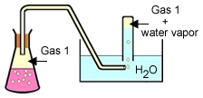

Initially the bottle is completely filled with water shown in the diagram. As oxygen gas is generated, the gas bubbles displace the water from the bottle. The oxygen gas collected in this way is not pure however. The total gas pressure is equal to the sum of the pressures exerted by the oxygen gas and the water vapor,

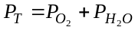

Consequently, we must take into consideration the pressure caused by the presence of water vapor when we calculate the amount of O₂ generated.

Skill 35.02 Example 1
A student collected a 90.0 mL sample of an unknown gas at 25ºC. The total pressure was 721.2 mm Hg. The water vapor pressure at 25ºC is . 23.76 mm Hg. What is the pressure of the dry gas? | 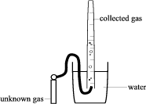

Skill 35.03: Use the ideal gas law to calculate the molar mass of a gas

Skill 35.03 Concepts

The ideal gas law can be used to calculate the molar mass of a gas sample. Suppose that the pressure, volume, and temperature are known for a gas sample of a given mass. The number of moles (n) in the sample can be calculated using the ideal gas law. Then the molar mass (grams per mole) can be calculated by dividing the known mass by the number of moles.

This is illustrated in the following example,

Example

A student collected a 90.0 mL sample of an unknown gas at 25ºC. The pressure of the dry gas was 721.2 mm Hg. The mass of the tank containing the unknown gas before the reaction was 1003.079 g. The mass of the tank containing the unknown gas after the reaction was 1003.065 g. What is the molar mass of the gas?

Solution

The molar mass of a gas can be expressed as follows

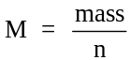

The moles of gas, n, can be calculated using the ideal gas equation, PV =nRT. Rearranging,

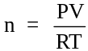

According to the data,

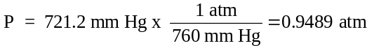

V = 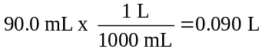

R = 0.0821

T = 25ºC +273 = 298 K

mass = 1003.079 g – 1003.065 g = 0.014 g

Substituting to find moles, n,

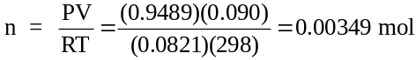

Substituting to find the molar mass,

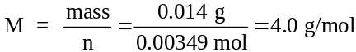

Skill 35.03 Example 1
Oxygen gas generated by the decomposition of potassium chlorate was collected by water displacement. The mass of the test tube and contents before the reaction was 23.00 g. The mass of the test tube and contents after the reaction was 22.84. The volume of oxygen collected at 24ºC and atmospheric pressure of 762 mm Hg was 128 mL. (vapor pressure H₂O @ 24ºC = 23.76 mm Hg)

- Calculate the pressure of the dry oxygen gas
- Calculate the mass of oxygen gas produced
- Calculate the moles of oxygen gas produced
- Calculate the experimental molar mass of the oxygen gas

Skill 35.04: Use the ideal gas law to calculate the density of a gas

Skill 35.04 Concepts

The ideal gas law can also be used to calculate the density of a gas. An equation showing the relationship between density, pressure, temperature, and molar mass can be derived from the ideal gas law, and the molar mass equation,

PV=nRT and

Rearranging the molar mass equation and substituting yields,

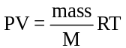

Rearranging the above equation,

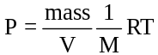

In the above equation, notice that D=mass/V. Substituting and rearranging once more,

PM = DRT

The above equation enables one to find the density of a gas if the pressure, temperature, and molar mass are known.

Skill 35.04 Example 1
What is the density of a sample of ammonia gas (NH3) if the pressure is 705 mm Hg and the temperature is 63ºC?

Set 35.0 Problems

- Three of the primary components of air are carbon dioxide, nitrogen, and oxygen. In a sample containing a mixture of these gases at one atmosphere, the partial pressures of carbon dioxide and nitrogen are given as P_{CO2} = 0.285 mm Hg and P_{N2} = 593.525 mm Hg. What is the partial pressure of oxygen?

- Determine the partial pressure of oxygen collected by water displacement if the water temperature is 20.0ºC and the total pressure of the gases in the collection bottle is 730.0 mm Hg. (vapor pressure of water at 20ºC = 17.5 mm Hg)

- A sample of oxygen gas is collected over water at a temperature of 35.0ºC when the barometric pressure reading is 742 mm Hg. What is the partial pressure of the dry gas? (vapor pressure of water at 35ºC = 42.2 mm Hg)

- A 2.5 L flask at 15ºC contains a mixture of N₂, He, and Ne. The partial pressures are 0.32 atm for N₂, 0.15 atm for He, and 0.42 atm for Ne.

(a) Calculate the total pressure of the mixture.
(b) Calculate the moles of each gas present in the mixture
(c) Calculate the volume in liters at STP occupied by He and Ne if the N₂ was removed selectively.

- At 28ºC and 740 mm Hg pressure, 1.00 L of an unidentified gas has a mass of 5.16 g. What is the molar mass of this gas?

- What is the molar mass of a gas if 0.427 g of the gas occupies a volume of 125 mL at 20.0ºC and 745 mm Hg pressure?

- One method for estimating the temperature of the center of the sun is based on the assumption that the center consists of gases that have an average molar mass of 2.00 g/mol. If the density of the center is 1.4 x 10³ g/L at a pressure of 1.30 x 10⁹ atm, calculate its temperature in Celsius.

- If the density of an unknown gas is 3.20 g/L at -18ºC and 1650 mm Hg. What is the molar mass of this gas?

- A rigid 5.00 L cylinder contains 24.5 g of N₂(g) and 28.0 g of O₂(g).

  - Calculate the total pressure, in atm, of the gas mixture in the cylinder at 298 K.

  - The temperature of the gas mixture in the cylinder is decreased to 280 K. Calculate each of the following:

- The partial pressusre, in atm of O₂(g) in the cylinder
- The partial pressure, in atm, of N₂(g) in the cylinder

- A student performs an experiment to determine the molar mass of an unknown gas. A small amount of the pure gas is released from a pressurized container and collected in a graduated tube over water at room temperature, as shown in the diagram below. Assume that:

- The gas is not appreciably soluble in water
- The gas collected in the graduated tube and the water are in thermal equilibrium
- A barometer, a thermometer, an analytical balance, and a table of the equilibrium vapor pressure of water at various temperatures are also available.

    - Write the equation(s) needed to calculate the molar mass of the gas

    - List the measurements that must be made in order to calculate the molar mass of the gas.

    - If the student fails to use information from the table of the equilibrium vapor pressures of water in the calculation, how would this affect the value of the molar mass? Explain.

Set 36: Gas Stoichiometry

Skill 36.01: solve volume-volume stoichiometry problems
Skill 36.02: solve volume-mole stoichiometry problems
Skill 36.03: solve volume-mass stoichiometry problems
Skill 36.04: solve mole-volume stoichiometry problems
Skill 36.05: solve mass-volume stoichiometry problems

Figure 1. Steps for solving gas stoichiometry problems
Type | Description | Steps
volume –volume | In volume-volume problem, you are given the volume of one substance and asked to calculate the volume of another substance in the chemical reaction. | volume given → volume unknown
volume-mole | In a volume-mole problem, you are given the volume of one substance and asked to find the moles of another substance in the chemical reaction | volume given → moles given → moles unknown
volume – mass | In a volume-mass problem, you are given the volume of one substance and asked to find the mass of another substance in the chemical reaction | volume given → moles given → moles unknown → mass unknown
moles –volume | In a mole-volume problem, you are given the moles of one substance and asked to find the volume of another in the chemical reaction | moles given → moles unknown → volume unknown
mass –volume | In a mass-volume problem, you are given the mass of one substance and asked to find the volume of another in the chemical reaction | mass given → moles given → moles unknown → volume unknown

Skill 36.01: solve volume-volume stoichiometry problems

Skill 36.01 Concepts

For gaseous reactants, or products, the coefficients in chemical equations not only indicate molar amounts and mole ratios, but also reveal volume ratios. Consider the reaction of hydrogen and oxygen to give water.

2H₂ + O₂ → 2H₂O

The following four expressions are true for the above reaction:

- 2 molecules hydrogen + 1 molecule oxygen → 2 molecules water
- 2 moles hydrogen + 1 mole oxygen → 2 moles water
- 4 grams hydrogen + 32 g oxygen → 36 g water
- 2 volumes hydrogen (L) + 1 volume oxygen (L) → 2 volumes water (L)

Although expressions (1) thru (3) are true whether the species in the reaction are gaseous, solids, or liquids, expression (4) is ONLY true when the species are gases.

Skill 36.01 Example 1
The following mixture of gases is confined to a flexible container. A spark causes the mixture to react forming H₂O. Assuming STP conditions and no resistance from the container,

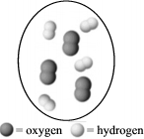
- What are the total moles of gases in the container after the reaction is complete?
- What is the final volume?

The following example illustrates how volume ratios can be used to solve volume-volume stoichiometry problems

Example

Propane C₃H₈ completely combusts according to the following equation,

C₃H₈ + 5O₂ → 3CO₂ + 4H₂O

What volume, in liters, of oxygen are required to completely combust 0.350 L of propane?

Solution

Step 1: identify the unknown: O₂

Step 2: identify the given: 0.350 L C₃H₈

Step 3: identify the volume ratio between the unknown and the given:

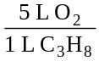

Step 4: multiply the volume of given by the volume ratio:

0.350 L C₃H₈ x = 1.75 moles O₂
Concept 36.01 Example 2
Propane C₃H₈ completely combusts according to the following equation,

C₃H₈ + 5O₂ → 3CO₂ + 4H₂O

What will be the volume of carbon dioxide produced in the reaction?

Skill 36.02: solve volume-mole stoichiometry problems

Skill 36.02 Concepts

In volume-mole stoichiometry problems, you are asked to calculate the moles of one substance given the volume of another. According to figure 1, the steps involved are as follows:

volume given → moles given → moles unknown

According to the “steps” above, in order to calculate the moles of unknown, an equation that relates the moles of given the volume of given is needed, and a conversion factor that relates the moles of unknown to the moles of given is needed

The following example, illustrates how this is done:

Example

Phosphorous readily reacts with atmospheric oxygen to form diphosphorous pentaoxide gas as shown below:

P₄ + 5O₂ → 2P₂O₅

If 2.0 L of oxygen gas react at 25ºC and 1 atm, how much, in moles, of diphosphorous pentaoxide gas can be produced?

Solution

Step 1: identify the unknown: P₂O₅

Step 2: identify the given: 2.0 moles O₂

Step 3: identify the equation that relates the moles of given to the volume of given

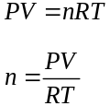

Step 4: identify the mole ratio between the unknown and the given:

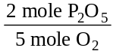

Step 5: calculate the moles of given using the ideal gas equation, then multiply the result by the mole ratio

To calculate the moles, the ideal gas equation is needed,
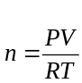

P = 1 atm
V = 2.0 L
R = 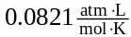
T = 25+273 = 298 K

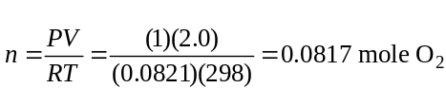

multiply the result by the mole ratio to find the moles of unknown,

0.0817 mol O₂ x = 0.0327 mole P₂O₅

Skill 36.02 Example 1
Methanol readily combusts as follows,

2CH₃OH(g) + 3O₂(g) → 2CO₂(g) + 4H₂O(g)

If 5.0 L of methanol reaction, how much, in moles, of water vapor will be produced?

Skill 36.03: solve volume-mass stoichiometry problems

Skill 36.03 Concepts

In volume-mass stoichiometry problems, you are asked to calculate the mass of one substance given the volume of another. According to figure 1, the steps involved are as follows:

volume given → moles given → moles unknown → mass unknown

According to the “steps” above, in order to calculate the moles of unknown, an equation that relates the moles of given to the volume given is needed, a conversion factor that relates moles unknown to moles given is needed, and a conversion factor that relates the mass of unknown to the moles of unknown is needed

The following example, illustrates how this is done:

Example

Phosphorous readily reacts with atmospheric oxygen to form diphosphorous pentaoxide gas as shown below:

P₄ + 5O₂ → 2P₂O₅

How much, in grams, of phosphorous will react with 2.0 L of oxygen gas react at 25ºC and 1 atm,

Solution

Step 1: identify the unknown: P₄

Step 2: identify the given: 2.0 moles O₂

Step 3: identify the equation that relates the moles of given to the volume of given

Step 4: identify the mole ratio between the unknown and the given:

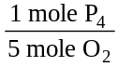

Step 5: identify the conversion factor that relates the mass of unknown to the moles of unknown

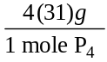

**notice that this is just the molar mass of the unknown

Step 6: calculate the moles of given using the ideal gas equation, multiply the result by the mole ratio and the mass-mole conversion factor

To find the moles of given, the ideal gas equation is needed,

P = 1 atm
V = 2.0 L
R =
T = 25+273 = 298 K

multiply the result by the mole ratio and the mass-mole conversion factor,

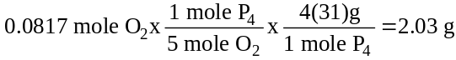

Skill 36.03 Example 1
Sodium reacts with water through single replacement as follows,

2Na(s) + 2H₂O(l) → 2NaOH(s) + H₂(g)

How much sodium is required to produce 500. L of hydrogen gas?

Skill 36.04: solve mole-volume stoichiometry problems

Skill 36.04 Concepts

In mole-volume stoichiometry problems, you are asked to calculate the volume of one substance given the moles of another. According to figure 1, the steps involved are as follows:

moles given → moles unknown → volume unknown

According to the “steps” above, in order to calculate the volume of unknown, a conversion factor that relates the moles of unknown to the moles of given is needed, and an equation that relates the volume of unknown to the moles of unknown is needed.

The following example, illustrates how this is done:

Example

Phosphorous readily reacts with atmospheric oxygen to form diphosphorous pentaoxide gas as shown below:

P₄ + 5O₂ → 2P₂O₅

If 3.0 moles of phosphorus react at 25ºC and 1 atm, how much, in liters, of diphosphorous pentaoxide gas can be produced?

Solution

Step 1: identify the unknown: P₂O₅

Step 2: identify the given: 3.0 moles P₄

Step 3: identify the mole ratio between the unknown and the given:

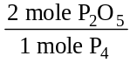

Step 4: identify the equation that relates the volume of unknown to the moles of unknown

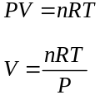

Step 5: multiply the moles of given by the mole ratio, then solve for volume using the ideal gas equation

3.0 moles P₄ x = 6.0 moles P₂O₅

To find the volume, the ideal gas equation is needed,
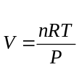

n = 6.0 moles
R =

T = 25+273 = 298 K
P = 1 atm

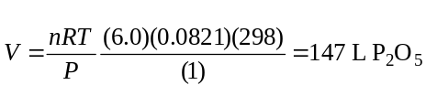

Skill 36.04 Example 1
Sodium reacts with water through single replacement as follows,

2Na(s) + 2H₂O(l) → 2NaOH(s) + H₂(g)

If 2.5 moles of sodium react, what volume of hydrogen gas will be produced?

Skill 36.05: solve mass-volume stoichiometry problems

Skill 36.05 Concepts

In mass-volume stoichiometry problems, you are asked to calculate the volume of one substance given the mass of another. According to figure 1, the steps involved are as follows:

mass given → moles given → moles unknown → volume unknown

According to the “steps” above, in order to calculate the volume of unknown, a conversion factor that relates the moles of given to the mass of given is needed, a conversion factor that relates the moles of unknown to the moles of given is needed, and an equation that relates the volume of unknown to the moles of unknown is needed.

The following example, illustrates how this is done:

Example

Phosphorous readily reacts with atmospheric oxygen to form diphosphorous pentaoxide gas as shown below:

P₄ + 5O₂ → 2P₂O₅

If 1.0 gram of phosphorus react at 25ºC and 1 atm, how much, in liters, of diphosphorous pentaoxide gas can be produced?

Solution

Step 1: identify the unknown: P₂O₅

Step 2: identify the given: 1.0 g P₄

Step 3: identify the conversion factor that relates the moles of given to the mass of given

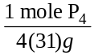

**notice that this is just the molar mass of the given

Step 4: identify the mole ratio between the unknown and the given:

Step 5: identify the equation that relates the volume of unknown to the moles of unknown

Step 6: multiply the moles of given by the mole-mass conversion factor and the mole ratio, then solve for volume using the ideal gas equation

1.0 g P₄ x x = 0.0161 moles P₂O₅

To find the volume, the ideal gas equation is needed,

n = 0.0161 moles
R =

T = 25+273 = 298 K
P = 1 atm

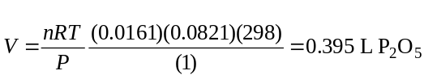

Skill 36.05 Example 1
Sodium reacts with water through single replacement as follows,

2Na(s) + 2H₂O(l) → 2NaOH(s) + H₂(g)

If 2.0 g of sodium react, what volume of hydrogen gas will be produced?

Set 36.0 Summary

In the early stages of solving stoichiometry problems it is useful to know what steps to combine for a given type of problem. For this reason, I have provided figure 2. Keep in mind however, you will not be permitted to use this on quizzes or exams. Only through practice will you acquire independence from this guide.

Figure 2. How to solve gas stoichiometry problems
Type | Steps
volume-volume | volume given x 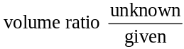= volume unknown
volume-moles | Use PV=nRT to find moles from volume  moles given x 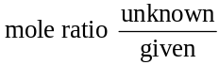 = moles unknown
volume – mass | Use PV=nRT to find moles from volume  moles given x x 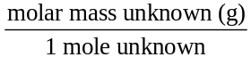= mass unknown (g)
mole - volume | moles given x = moles unknown  use PV=nRT to find volume from moles
mass - volume | mass given x 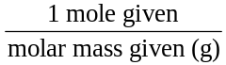x = moles unknown  use PV=nRT to find volume from moles

Set 36.0 Problems

- Given:
1 C₃H₈ + 5 O₂ → 3 CO₂ + 4 H₂O
If the reaction is started with 7.5 L of propane, how many liters of oxygen will be required?
- Given :
2 Al + 3 H₂SO₄ → Al₂(SO₄)₃ + 3 H₂
If 3.5 moles of acid is consumed in a reaction, how many liters of hydrogen gas will be produced at STP ?
- Given :
4 NH₃ + 5 O₂ → 4 NO + 6 H₂O
If the reaction starts with 5 mol of ammonia, how many liters of oxygen will be required at STP?
- The following mixture of gases is confined to a 22.4 L rigid container at 273 K. A spark causes the mixture to react forming H₂O.
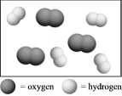
- What are the total moles of gases in the container after the reaction is complete?
- What is the final pressure
- The following mixture of gases is confined to a flexible container at STP. A spark causes the mixture to react forming H₂O.
  - What are the total moles of gases in the container after the reaction is complete?
  - What is the final volume

- Carbon monoxide reacts with oxygen to produce carbon dioxide according to the following reaction,

CO + O₂ → CO₂

If 5.0 L of carbon monoxide reacts,

- How many liters of oxygen are required?
- How many liters of carbon dioxide are produced?

- Acetylene (C₂H₂) undergoes combustion to produce carbon dioxide and water vapor according to the following reaction,

C₂H₂ + O₂ → CO₂ + H₂O

If 75.0 L of CO₂ was produced,

- How much, in moles, or C₂H₂ was used?
- How much, in moles, of H₂O was produced?

- When 22.4 L of oxygen reacts at STP,

Mg + O₂ → MgO

- How much, in moles, of magnesium oxide can be produced?
- How much, in grams, of magnesium is consumed?

- When copper(II) oxide reacted with hydrogen as shown, 2.5 moles of water was collected at 25ºC and 1 atm

CuO + H₂ → Cu + H₂O

What volume, in liters, of hydrogen reacted?

- When potassium iodide reacted with chlorine, 3.0 g of potassium chloride was recovered at 20ºC and 755 mm Hg.

KI + Cl₂ → KCl + I₂

What volume of chlorine gas was consumed?

